**Lab 1**

**Q1. Working with toString() method in java.**

**Object class toString method:-**

**public String toString()**

**{**

**return getClass().getName()+"@"+Integer.toHexString(hashCode());**

**}**

**Source code:**

**class Student**

**{**

**public int r;**

**public String name;**

**void getData(int r, String name)**

**{**

**this.r = r;**

**this.name = name;**

**}**

**void display()**

**{**

**System.out.println("Roll no is : "+r);**

**System.out.println("Name is : " +name);**

**}**

**void show()**

**{**

**System.out.println("Name: "+name+" Roll number :"+r);**

**}**

**public String toString()**

**{**

**return "Name is :"+name+" Roll no is : "+r;**

**}**

**}**

**class DemoStudent**

**{**

**public static void main(String[] args)**

**{**

**Student obj1 = new Student();**

**obj1.getData(101, "Rakesh");**

**obj1.display();**

**obj1.show();**

**Student obj2 = new Student();**

**obj2.getData(102, "Dhruv");**

**obj2.display();**

**obj2.show();**

**System.out.println(obj1);**

**System.out.println(obj2);**

**}**

**}**

**Output:**

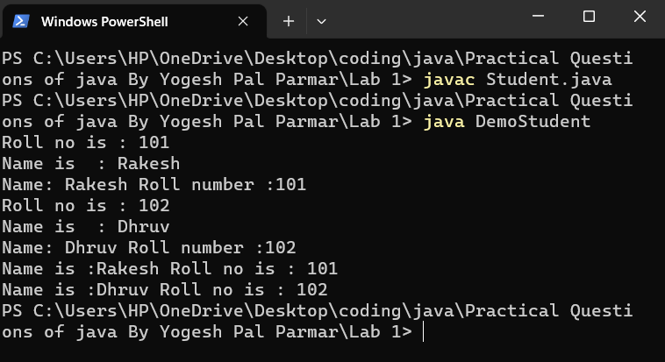

**Q2. Convert the program 1 from toString function to parameterized constructor.**

**Source code:**

**class StudentDemo**

**{**

**public int r;**

**public String name;**

**void getData(int r, String name)**

**{**

**this.r = r;**

**this.name = name;**

**}**

**void display()**

**{**

**System.out.println("Roll no is : "+ r);**

**System.out.println("Name is : " + name);**

**}**

**void show()**

**{**

**System.out.println("Name: "+ name +" Roll number :" + r);**

**}**

**StudentDemo(int rollNo, String name)**

**{**

**System.out.println("Name is : " + name + "Roll number is : " + rollNo);**

**}**

**}**

**class Demo**

**{**

**public static void main(String[] args)**

**{**

**StudentDemo obj1 = new StudentDemo(101, "Rakesh");**

**obj1.getData(101, "Rakesh");**

**obj1.display();**

**obj1.show();**

**StudentDemo obj2 = new StudentDemo(102, "Dhruv");**

**obj2.getData(102, "Dhruv");**

**obj2.display();**

**obj2.show();**

**System.out.println(obj1);**

**System.out.println(obj2);**

**}**

**}**

**Output:**

